CI :

Solution : **Build** and **Test** code for every commit if any wrong => notify coder. This is Continuous Integration

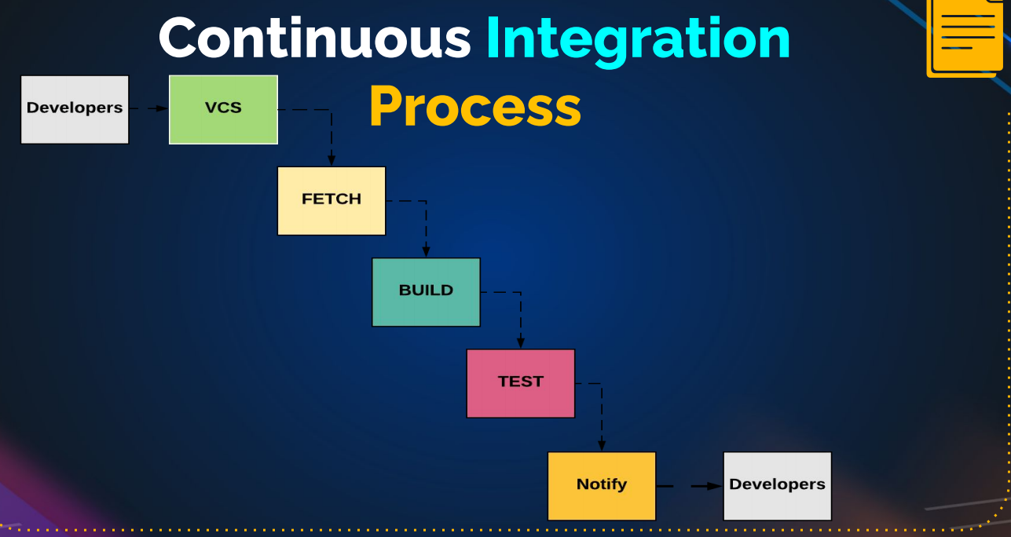

* Coder stop doing things, fix error.

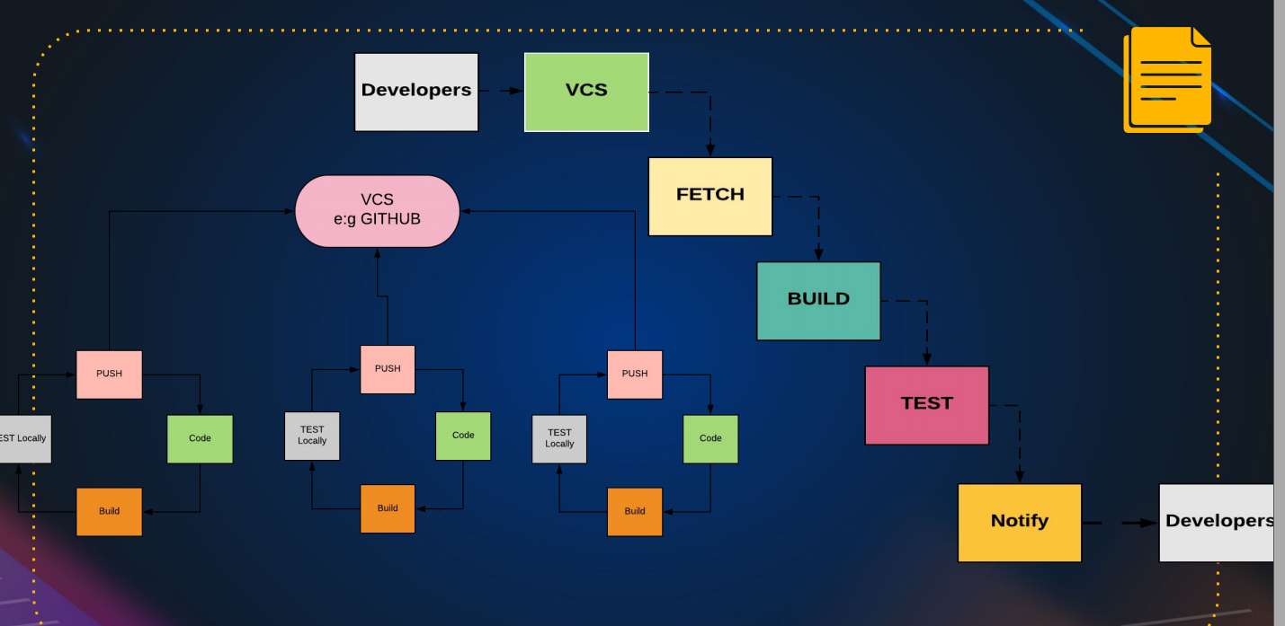

**Jenkin** is tools for automate CI

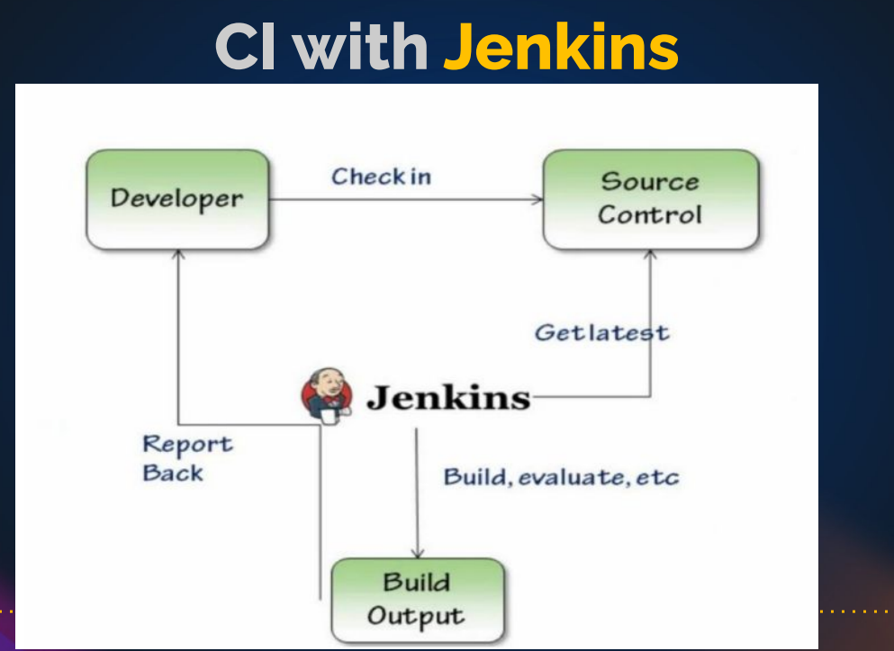

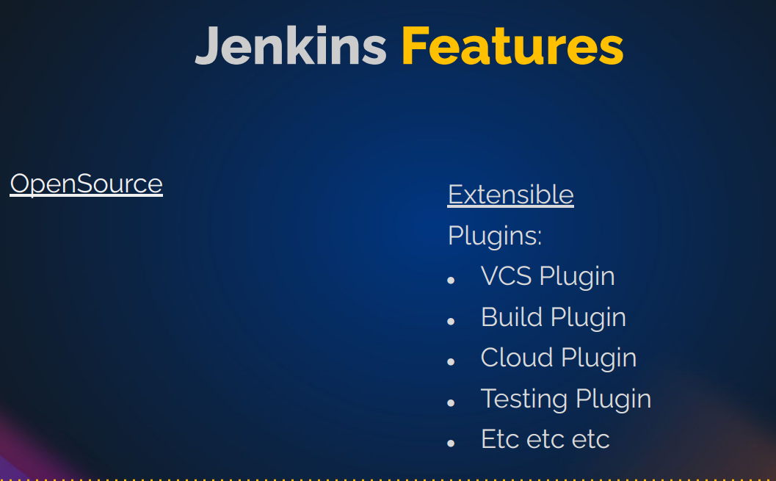

Two main feature: opensource and extensible.

Use as CI or CD…